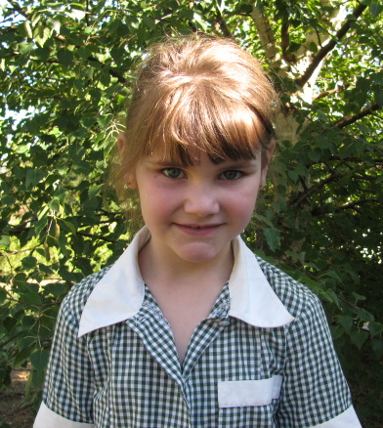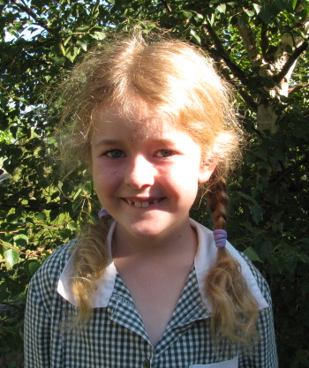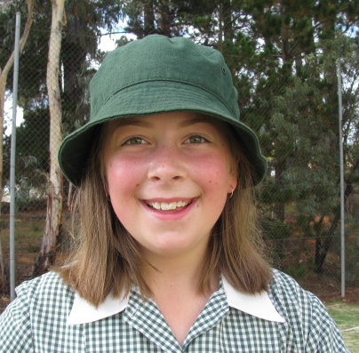

Jerangle Public School Newsletter

Week 8, Term 3 Mrs Sonja Thorvaldson
8th September, 2010 Principal Jerangle Public School

From the Principal’s Desk

The last two weeks the children have been closely monitoring the weather patterns in order to participate in this term’s skiing program. They were disappointed that the first day was cancelled due to bad weather but were delighted last week when the weather lifted slightly enabling them to join Dalgety at Perisher for a fun day on the snow. It was wonderful to see both schools work together to have so much fun. As always the children conducted themselves in a very mature manner and respected the public who were also using the Nordic Shelter for the day. Everyone showed great improvement from last year and I can see it won’t be too long before some members of the class overtake me in the Scoop-and-Monkey race! We plan to go skiing again tomorrow and cross our fingers that the weather is nice and sunny with not too much wind.
Bob Aston (School Education Director) visited the school last Friday to see how the children are progressing and was suitably impressed at all the wonderful work being carried out with in the school. I was pleased to be able to report how each and every child has shown growth in all subject areas. Mr Aston was also keen to view the new classroom and see first hand how the lessons are being conducted. He left commenting on the wonderful impact the new classroom has made on the school and praised all those that have helped create such a terrific learning environment.
Fruit and Veg Month 
September is officially Fruit and Veg Month and the school has decided to take on the Live Outside the Box Challenge again this year. Last year we saw many children change their eating habits and leisure activities to improve their health and well being. We hope to be even healthier this year.

Premiers Reading Challenge
The Premiers Reading Challenge has now been entered into the computer and I am pleased to say that everyone at the school managed to complete their own challenge. The program is designed to expand the children’s reading and expose them to very different types of books. I feel that this was achieved since a comment floated back to the school, “ …. this reading challenge is great because we (the parents) get to read all sorts of interesting books from the library not just the home readers each night.”
You can still continue to read Premiers Reading Challenge books from the library or you may even find some other interesting books on the library shelves to take home to entertain your parents.
Congratulations Everyone!


School Buildings Progress
Negotiations are continuing with the construction company to re install the Interactive whiteboard and video conferencing equipment. As yet there has been no solution to who will actually do the work but I am hoping that it won’t be too long before the children can once again link to other schools and share their lessons.
Recently the school applied for funding to cover the pathway from the library to the classroom and just last week the DET approved our application. This is great news especially since we all love the rain but don’t want the children to get wet moving from room to room. The only hitch is that the work may take 12 to 18 months to commence.


Skiing Program
Although the day was a little windy the school children enjoyed a day skiing at Perisher with Dalgety school. The sun shone for the morning and everyone tested out their skis and ski legs. After recess everyone joined in for some great relays packed with loads of fun. I’m not too sure if the parents enjoyed themselves more than the children but it certainly was a good day for everyone.

Spring Working Bee.
This is going to be an event not to be missed!!!! The school needs your help to kick start some initiatives during the spring growing season. As the saying goes – More hands make light work. So come and join in for a fun filled morning at the school on Sunday 31st October and have your say in how the new look Jerangle school will be this summer.
Kindy Start 
Next Term will see the start of this year’s Kindy Start Program. Children who are anticipating to attend school next year will be invited to join the class one day a week for the first 7 weeks of next Term. During this time the children will become familiar with some of the school routines and will make beginning school not so daunting in February.

Playground Equipment
The school’s playground equipment is going to assessed for safety issues and to see if it complies with the current safety standards. This will help the prioritise work needed during the working bee in October.

Coles Sports for Schools
Coles is having a promotion at present to encourage young people to take up sport as a leisure activity. If you shop at Coles, Coles online, Bi-lo or Pick’nPay you can earn points to buy sporting equipment for the school.
This is how it works:
*Shop at Coles and spend more than $10 to get a Coles Sport for School Voucher.
*Return the vouchers to Jerangle school and place in collection box in office.
*Watch our vouchers grow in numbers and think of all the great sporting equipment the children can enjoy next year.
*This challenge has already started and is open to all friends and family who shop at Coles and is on until Sunday 31st October – so start shopping!

NSW Rural Fire Service
A new electronic newsletter called Firewise eNews will be launched in August as a tool to assist the community to identify ways to protect themselves, their family, pets and their property from the impacts of a fire. Firewise eNews, will be distributed quarterly by email and will contain bush fire safety news, current issues and upcoming fire safety events. It will also communicate new programs, projects and initiatives to help the community prepare for a bush fire and keep their family safe.
All are invited to subscribe to this eNewsletter to learn what to do before, during and after a fire. Subscribing can be done simply and easily by visiting the RFS website www.rfs.nsw.gov.au and following the links.

Merit Awards 
Congratulations to all those who have been working hard to achieve Merit Awards and Certificates. This week we celebrate the following members of the school in their achievements.
3rd September 2010
Merit Certificate David Constance
Sports Award Dustin Hall
Work of the week Caitlin Galwey
Reading Award Angela Constance

Planner Calender – Term 3 2010
Week | Monday | Tuesday | Wednesday | Thursday | Friday | Sat/Sun
8  Landcare Week | 6 Sept  Skiing day  postponed | 7 Sept  Life Education - Michelago | 8 Sept | 9 Sept  Possible skiing day | 10 Sept | 11/12 Sept
9  Book Week | 13 Sept  Alice in Wonderland – Cooma North | 14 Sept  CWA Scotland Day | 15 Sept | 16 Sept  Reading Under the Covers | 17 Sept | 18/19 Sept
10  Bike Week | 20 Sept | 21 Sept | 22 Sept | 23 Sept  Muga Cottage - Canberra | 24 Sept | 25/26 Sept
Holidays | 27 Sept | 28 Sept | 29 Sept | 30 Sept | 1 Oct | 2/3 Oct
Holidays | 4 Oct | 5 Oct | 6 Oct | 7 Oct | 8 Oct | 9/10 Oct
Term 4 Week 1  Water Week | 11 Oct | 12 Oct | 13 Oct | 14 Oct | 15 Oct | 16/17 Oct
2 | 18 Oct | 19 Oct | 20 Oct | 21 Oct  Stage 3 Camp at Coomba | 22 Oct  Stage 3 Camp at Coomba | 23/24 Oct
3 | 25 Oct | 26 Oct | 27 Oct | 28 Oct | 29 Oct | 30 Oct  31 Oct  Working Bee
4 | 1 Nov | 2 Nov | 3 Nov | 4 Nov | 5 Nov | 6/7 Nov
5 | 8 Nov | 9 Nov  Numeralla day | 10 Nov | 11 Nov | 12 Nov | 13/14 Nov
6 | 15 Nov | 16 Nov | 17 Nov | 18 Nov | 19 Nov  Walk to Mt Kosciuszko | 20/21 Nov
7 | 22 Nov | 23 Nov | 24 Nov | 25 Nov  Visit Bournda Enviro. Ed. Centre | 26 Nov | 27/28 Nov
8 | 29 Nov  Swimming | 30 Nov  Swimming | 1 Dec  Swimming | 2 Dec  Swimming | 3 Dec  Swimming | 4/5 Dec
9 | 6 Dec  Swimming | 7 Dec  Swimming | 8 Dec  Swimming | 9 Dec  Swimming | 10 Dec  Swimming | 11/12 Dec
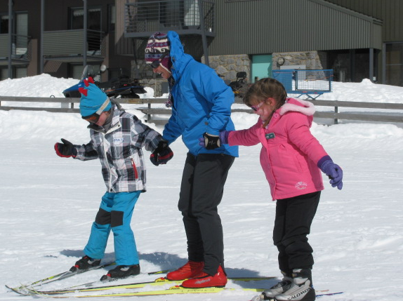Kids Corner 

My Journal

On Fathers Day I gave Dad a tie.

We had a picnic and Ella found a lamb.

I had fun.

By Wynn Hickey (Kindergarten)
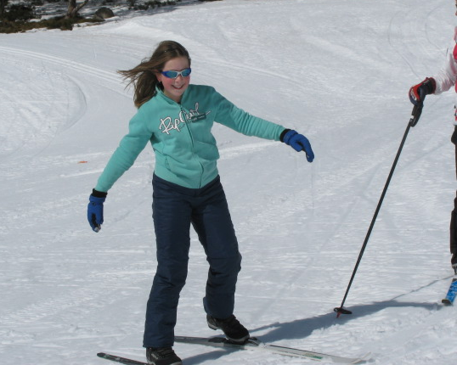
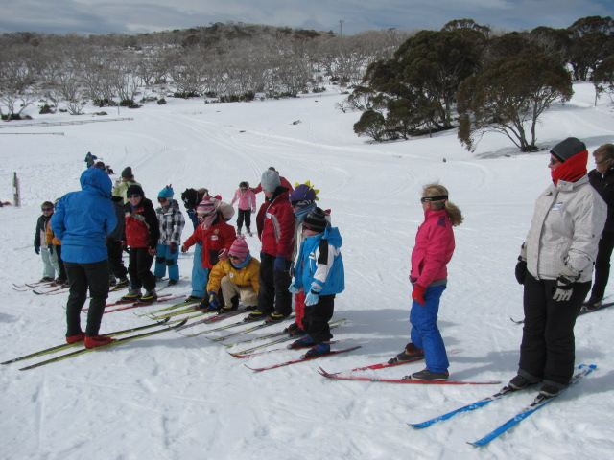

David enjoying a rest from standing!

The First Fleet Landing

26th Jan 1788.
The anchors rattled out, the officers shouted orders and the ships crews took down the sails. The heat of the midsummers sun beat down on the First Fleeters as they viewed their surroundings in uneasy silence. Lieutenant William Collins went ashore with a small group of convicts, cleared a patch of ground and raised the British flag. As the day wore on, the quiet wooded cove became a hive of activity. Stores were unloaded, trees and undergrowth were cleared, tents pitched, cooking fires started and a blacksmiths forge set up.

(an extract from Caitlin’s First Fleet Contract)

By Caitlin Galwey (Year 6)
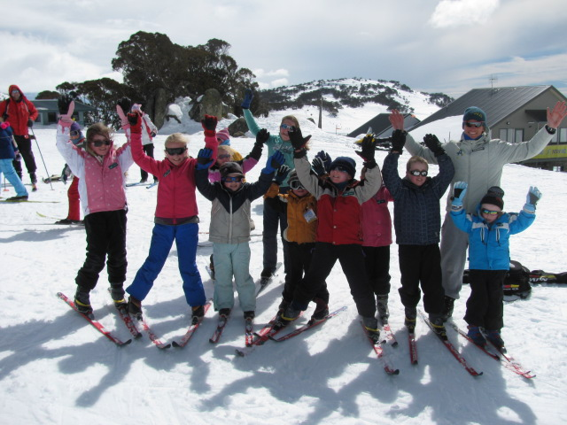
Our Olympian Ben Sim came to check out our skiing progress.
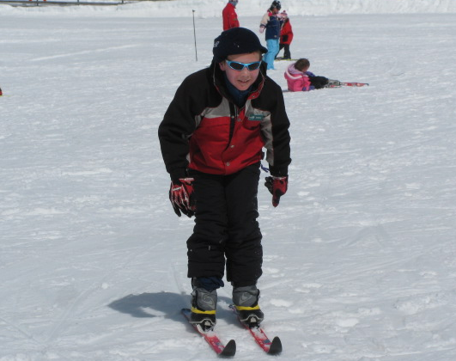
Going fast is so much fun!!!
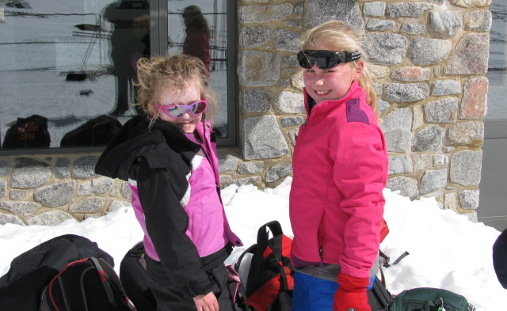
Time for lunch anyone?
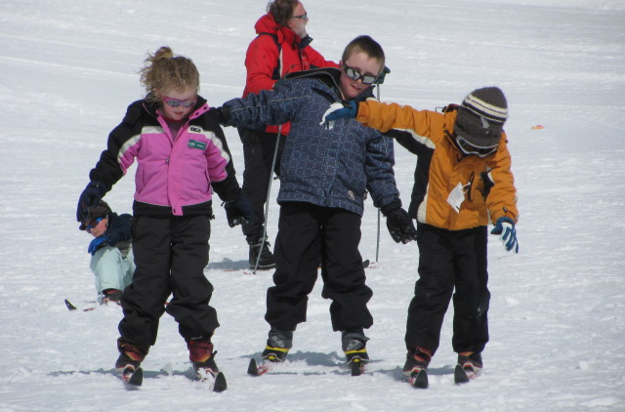
I think we are all going to fall!!!!




